O’Bannon Bank Alert Set Up Instructions

To set up email or text alerts on account activity, please follow the instructions below.

Log into online banking.
Select Options -Alerts - Events (See below)
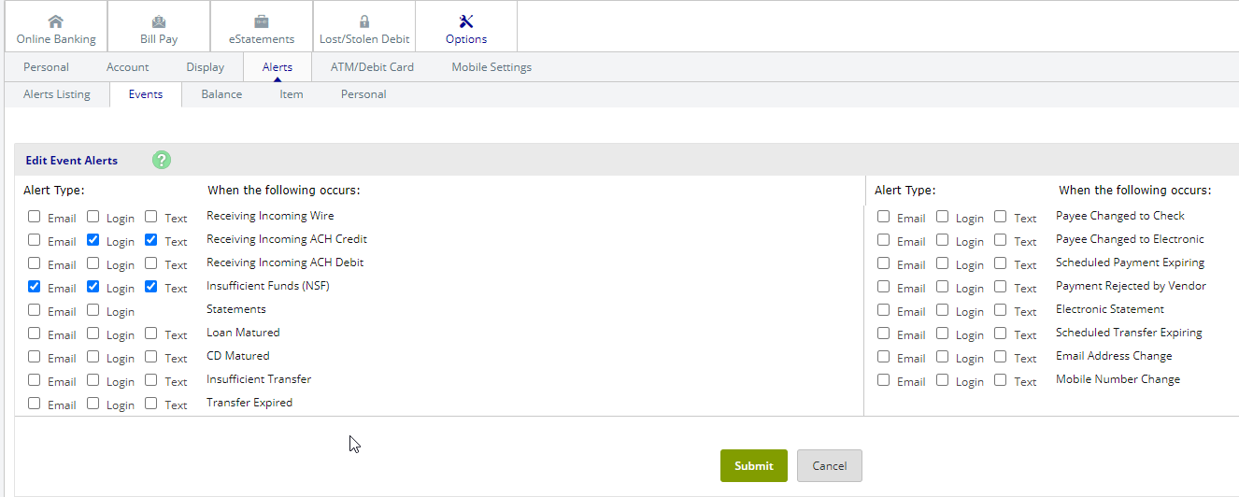
Choose desired alert types and submit.

Balance Alerts are also available. To enable a balance alert, choose a delivery option, the desired account, the condition, and the target balance.
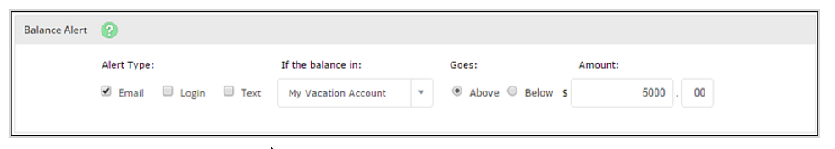

Note: For Text Alerts you must have your mobile phone number and wireless provider selected.
Select Options – Mobile Settings – Text Mobile Settings, complete information and then submit.

If you have any questions, please call Customer Service at 417-345-2251.

